Experiment 2
Description: Create a simple cloud software application for Flight Reservation System using any Cloud Service Provider to demonstrate SaaS.
Aim
To design a cloud-based flight reservation system and deploy it under a SaaS model.
Procedure
- Select cloud platform for development.
- Create modules: User Login, Flight Search, Booking Form.
- Connect backend storage (cloud database).
- Deploy the system as a service.
- Test booking and search flows.
Output:
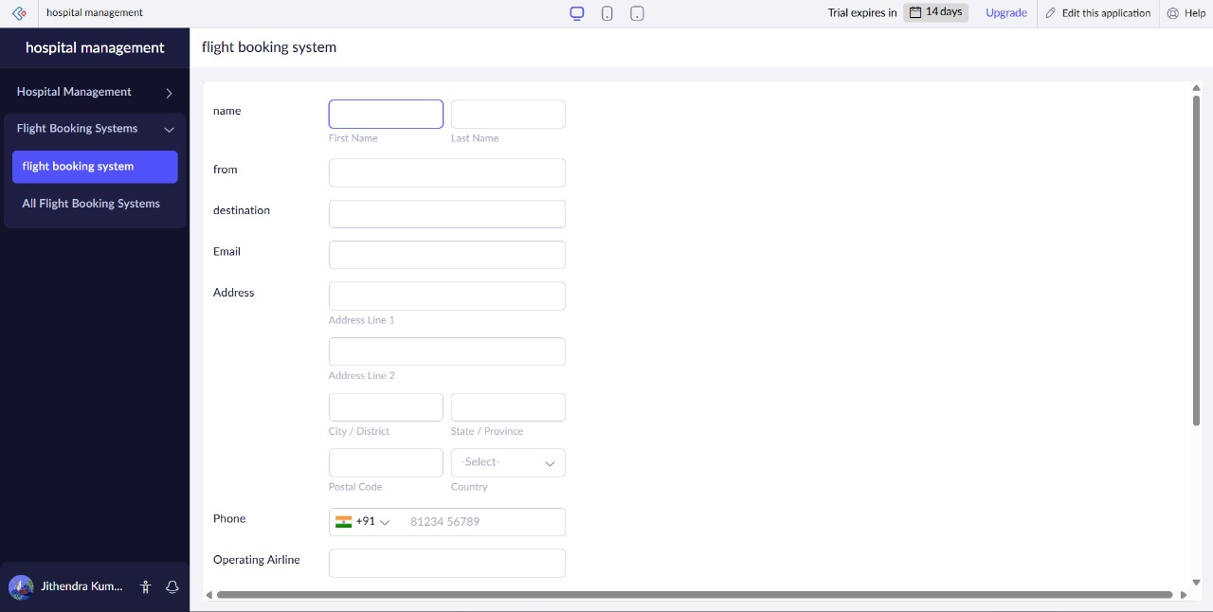
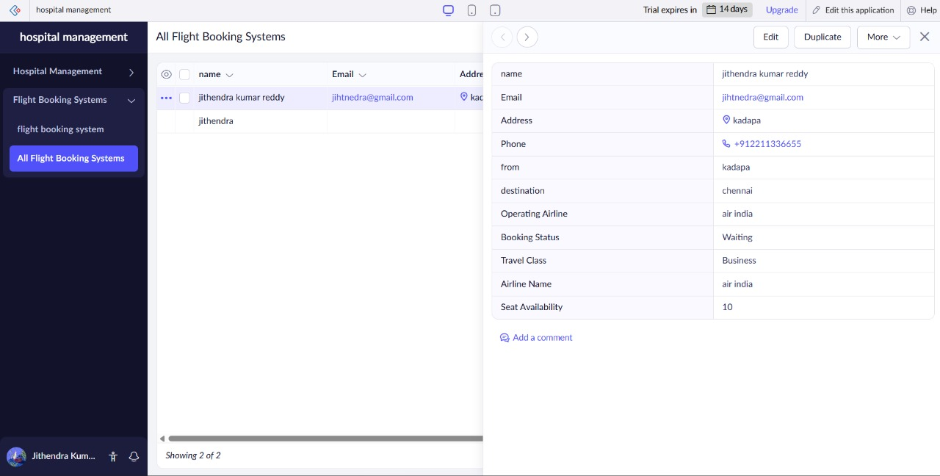
Result
The flight reservation system worked successfully with cloud-based deployment.

